|  |
| --- |
| DXC’s |
| ConnectED |
| Client Alchemy |

|  |
| --- |
| *Version 2.4.0*  *Date:06/03/2024* |

**TABLE OF CONTENTS**

1. Introduction

2. Platform Overview

3. Key Objectives and Goals

4. Requirements

* Functional Requirements
* Non-Functional Requirements

5. Assumptions and Prerequisites

6. Architecture and Design

7. Data Model and Integration

8. User Flows and Transactions

9. Security and Compliance

10. Future Enhancements

11. Conclusion

**1. Introduction:**

The ConnectED - Professional Social Networking Platform’s High-Level Design (HLD) document serves as a comprehensive guide detailing the architecture, functionalities, and essential elements of a Professional Social Network. Its purpose is to furnish a meticulously structured blueprint, facilitating the systematic development and deployment of the platform.

**2. Platform Overview:**

The ConnectED - Professional Social Networking Platform aims to create a dynamic environment for professionals to connect, collaborate, and advance their careers. It will facilitate networking, knowledge sharing, and career opportunities across diverse industries.

**3. Key Objectives and Goals:**

The main objectives of the platform include fostering meaningful connections between professionals, promoting knowledge exchange, supporting career growth, and ensuring user privacy and security.

**4. Requirements:**

**Functional Requirements:**

**User Authentication and Authorization**: Users can securely create accounts and log in, with different access levels and safety measures like email/SMS verification.

**Profile Management**: Users control their profiles, adding personal details, work history, and education.

**Content Creation and Publishing**: Users can create various content types like posts and articles, customize them, and share them with publicly.

**Social Interactions**: Users connect with others, and engage with their content through likes, comments, and shares.

**Messaging and Notifications**: Users can send private messages, receive notifications for new connections and interactions, and customize their notification preferences.

**Search and Discovery**: Users search for other users, content, and groups, and recommendations to discover relevant connections and content.

**Non-Functional Requirements:**

**Performance**:

* The system responds quickly (Ensure response times for search processes are within 3 seconds.)
* Page load times should be minimized.

**Scalability:**

* It can grow to accommodate more users and content by distributing the load across multiple servers.
* Horizontal scaling should be supported to distribute the load across multiple servers.

**Security**:

* User data is protected with encryption, strict access controls.
* Measures should be in place to prevent unauthorized access to user accounts and data.
* Secure data storage.

**Availability**:

* The system is always accessible to users, with mechanisms in place to minimize downtime.
* Redundancy and failover mechanisms should be in place to minimize downtime.

**Reliability**:

* It operates consistently without frequent failures, ensuring a dependable user experience.
* Regular backups of data should be performed to prevent data loss.

**Usability**:

* The interface is easy to use, features are labelled clearly, and accessibility features are included for users with disabilities.

**5. Assumptions and Prerequisites:**

**Java and Spring Boot**:

* These are used to create the core functionalities of the platform, such as user authentication, profile management, used for building the backend logic and data handling.
* A framework that simplifies the development of Java-based web applications, providing tools and features for easier implementation.

**AngularJS**:

* A frontend JavaScript framework used for creating dynamic and interactive user interfaces.

**MySQL**:

* These databases store user data and structured data like user profiles, post information, providing a reliable storage solution for the platform's data.

**Docker**:

* It’s used to containerize the application, making it easier to deploy and manage across different environments while ensuring consistency.

**AWS**:

* Amazon Web Services is utilized for hosting, scaling, and managing the application infrastructure, providing the necessary computing power and networking capabilities.

**Other Tools and Frameworks**: Various other tools and frameworks mentioned in the document are used for testing, deployment automation, and design prototyping to ensure the platform's quality and efficiency.

**6. Architecture and Design:**

The platform will adopt a microservices architecture for scalability and flexibility, in a 3-tier structure with separate modules for user management, content management, social interaction, messaging, and search and discovery.

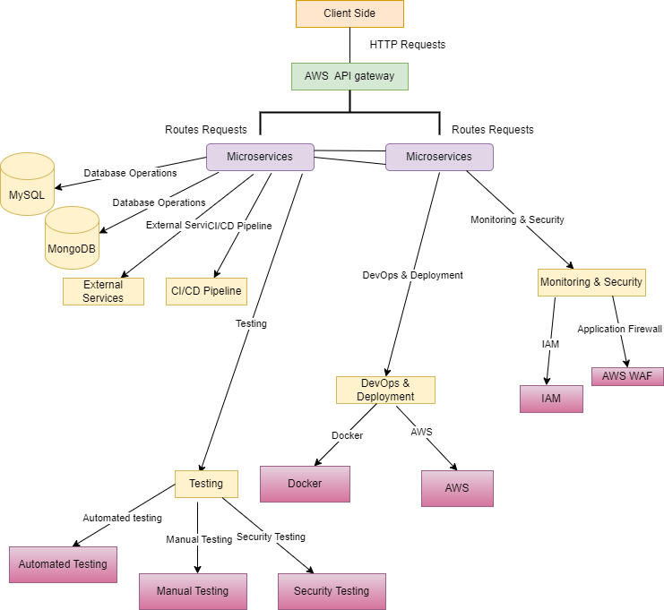

Figure : Architectural diagram

**7. Data Model and Integration:**

Data will be stored in relational (MySQL) databases, with integration points for third-party services such as authentication providers and analytics tools.

**8. User Flows and Transactions:**

**Registration**: This is where you create an account on the platform by providing your details like name, email, and password.

**Authentication**: After registration, you log in to your account securely using your username/email and password.

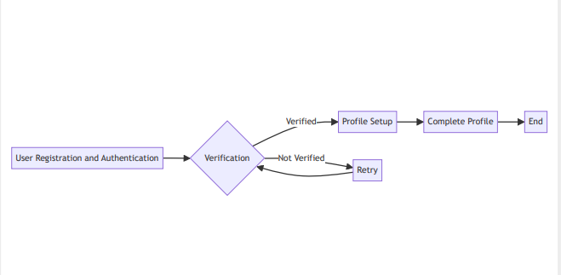

Figure : User authentication and authorization

**Profile Management**: Once logged in, you can customize your profile by adding information about yourself such as your job title, skills, and interests.

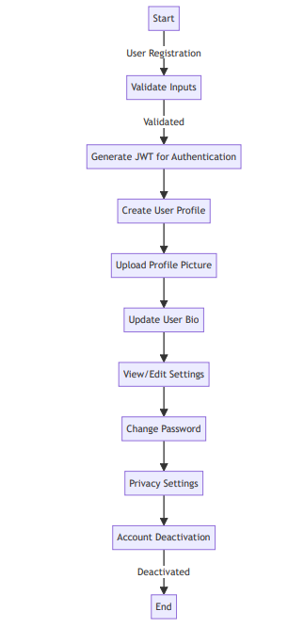

Figure : User profile Management

**Content Creation**: You can create and share various types of content like articles, images, or videos to express yourself or share information with others.

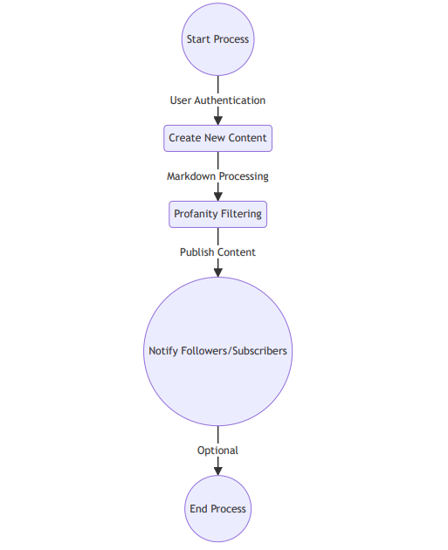

Figure : Content creation and Publishing

**Social Interactions**: You can engage with other users by liking, commenting, or sharing their content, fostering connections and interactions within the platform.

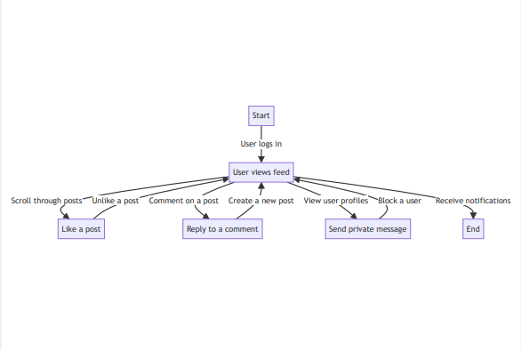

Figure : Social Interaction

**Messaging**: This feature enables users to send messages for one-on-one communication within the ConnectED.

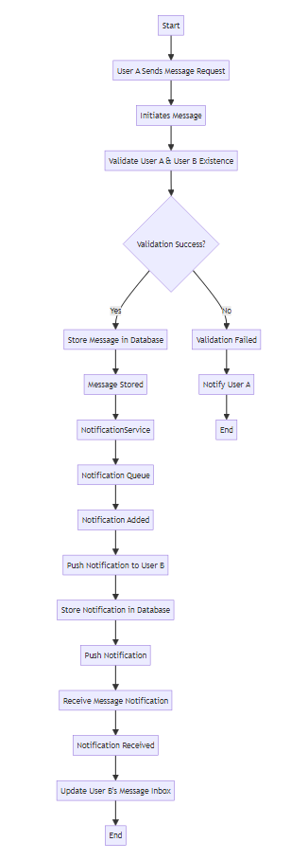

Figure : Messaging and Notification

**Content Discovery**: You can explore and discover new content, users, or groups based on your interests through search features or recommendations.

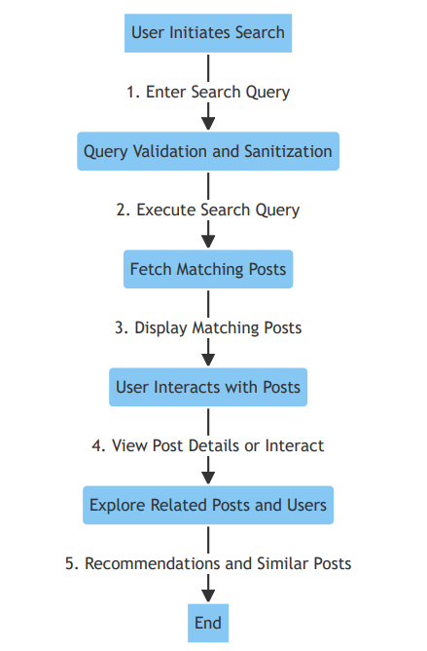

Figure : Search and Discovery

**Notification:** Implement logic to generate notifications whenever relevant events occur, such as likes, comments, new messages.

Figure : Notification

**9. Security and Compliance:**

The platform will implement robust security measures including authentication, authorization, and compliance with data privacy regulations.

**10. Future Enhancements:**

Future enhancements may include advanced analytics, personalized recommendations, community building tools, monetization options, and technology upgrades to meet evolving user needs.

**11. Conclusion:**

In conclusion, the presented high-level design for ConnectED encapsulates a robust blueprint for the development of a cutting-edge social media platform. Through meticulous consideration of business objectives, technical intricacies, and data management strategies, ConnectED aims to establish itself as a premier platform, fostering user engagement, privacy, and security while delivering a seamless experience across various devices. By harnessing contemporary technologies like microservices architecture, cloud infrastructure, and containerization, ConnectED endeavour’s to achieve unparalleled performance, scalability, and reliability. Furthermore, its integration capabilities with third-party services and a meticulously crafted API design ensure effortless interactions and future adaptability. With a commitment to continuous enhancement and innovation, ConnectED is primed to not only meet but exceed the evolving demands of its users, thereby maintaining its competitive edge in the dynamic realm of social media.Top of Form